THE EVOLUTION OF THE HAN WEDDING DRESS DESIGN RESEARCH AND INNOVATION

Gu yanping¹, Rose Dahlina Rusli²
^{1,2}College of Creative Arts，Universiti Teknologi MARA, Malaysia, Shah Alam, Selangor
Darul Ehsan, 40450,Malaysia.

Corresponding author: 2022707611@student.uitm.edu.my¹

Received: 19th July 2024
Accepted: 11th September 2024
Published: 23rd October 2024

ABSTRACT

China's long history has given birth to a colorful folk culture, and weddings are a significant part of life. The Chinese often use the term "married" to describe one's marital status, and wedding attire plays a crucial role in this cultural expression. Particularly in China’s dominant ethnic group, the Han, wedding dress traditions are something people pay great attention to. This article explores the evolution of Han wedding attire, detailing how it has changed since the Zhou Dynasty, up through the reforms and opening to the outside world. Throughout the dynasties, Han wedding dresses have exhibited unique characteristics and differences. With the economic, political, and cultural developments during the early Republic era, the grand and solemn traditional wedding dress gradually became westernized. However, Han Chinese traditional wedding attire remains a living cultural symbol, embodying the unique, beautiful, and mysterious essence of ancient Oriental culture, and representing the Han nationality. In designing modern Han wedding dresses, it is important to create designs that are aligned with contemporary trends while preserving the distinct characteristics of Han culture. By incorporating elements from different dynasties, such as traditional patterns, colors, fabrics, and shapes, alongside modern techniques and some western influences, innovation in Han wedding dress design can be achieved. Furthermore, through combining this research with personal innovation design practices, we can continue to inherit and carry forward the tradition of Han wedding attire, making a lasting contribution to its preservation.

Keywords: the Han nationality, wedding dress, development trend, Innovative design

INTRODUCTION

Since ancient times, wedding dresses have been an essential part of weddings in Chinese culture. From the Zhou Dynasty onward, wedding etiquette and attire have undergone a long process of inheritance and refinement. However, with the passage of time and the influence of cultural diversity, modern Han wedding dresses now incorporate both traditional and Western styles, offering a broader range of choices for Chinese people. This raises the question: how can we protect and continue the tradition of Han wedding dresses in a meaningful way?

To truly preserve this heritage, we must strive to maintain a "Chinese essence" in wedding fashion, celebrating the cultural significance of traditional Han wedding dresses while also adapting to modern influences. By blending traditional elements with Western aesthetics, we can create designs that not only honor the past but also appeal to contemporary tastes. This paper explores how modern wedding dress design can seamlessly integrate traditional Han Chinese elements, highlighting their cultural and artistic value. In a rapidly evolving fashion industry, preserving the rich heritage of traditional wedding attire while innovating for modern tastes is a key challenge. This research aims to address that challenge, ensuring that the cultural identity and historical significance of Han wedding dresses continue to flourish in contemporary fashion.

THE DEVELOPMENT TREND OF MODERN CHINESE HAN WEDDING DRESSES

With the progress of society and technology, and the change of ideas and concepts, there is still a lot of room for the development of wedding dresses in my country. After understanding the history of traditional Han wedding dresses, what will people wear at future weddings in China? What will the style of wedding dresses be in the future?(Qi, 2011b)

  - Style develops towards personalization

The economic development of contemporary society has led to a shift in consumer values, where people seek both material and spiritual fulfillment. Today, many consumers want to be actively involved in the design process of their wedding dresses, tailoring these garments to reflect their unique preferences and life stories(Muhua, 2021). This shift aligns with the growing emphasis on personalization in wedding dress design. As Ms. Cai Meiyue, a prominent figure in the industry, notes: “A woman's love, once in a lifetime, should be witnessed by her own wedding dress, not merely through photographs in a rented gown" (Dai, 1998). This view emphasizes the cultural significance of wedding dresses, not just as garments, but as heirlooms that capture personal milestones and emotions, passed down through generations.

Furthermore, the market's brand marketing strategies reflect this move towards personalization. For instance, brands like Fapat have pioneered innovative concepts such as "password customization," which focuses on meeting the unique preferences of grooms through modern customization techniques, blending tradition with contemporary needs (Feng Zemin, 2001). The trend indicates that wedding dress customization has evolved from being a luxury to a cultural practice, where individuals can express their identities through bespoke designs that transcend mere fashion(Hua, 2000).

  - Combination of Western elements with traditional Chinese elements

With the development of economic globalization today, the trend of integration of Chinese and Western clothing culture has also been unprecedentedly strengthened. Looking back on the development of Chinese and Western wedding dresses, we will find that the phenomenon of combining Chinese and Western styles began to appear in the late Qing Dynasty and the early Republic of China(Fang, 2019). The Chinese fashion industry is integrating Western fashion elements into traditional clothing design, integrating the ancient spirit into the future spirit, and complementing the different charms expressed under the different philosophical and aesthetic concepts of the East and the West(Huang, 2012). While exploring the "integration of Chinese and Western cultures", we should take the revitalization of national culture as our responsibility. We should not blindly "worship the West" or "keep to ourselves"(Gao, 2005). We should reasonably grasp the use of the past for the present and the use of the West for China.

  - Fashionable application of Chinese traditional elements

In the retro trend in recent years, we must not forget fashion while revising the past. Tradition is the crystallization of fashion and the driving force of fashion(Wang, 2012). In order to meet the aesthetic trends of consumers, designers continue to innovate and design new fashion clothing to meet people's aesthetic desires(Qiu, 2014). Modern people's life concepts are inseparable from the concept of fashionable life, so that Chinese traditional culture will enter the international stage and people's lives in a new way, thus promoting the development of wedding dresses in my country(Qi, 2011b). Don't forget the importance of inheritance and the way of innovation, and shape the elements of traditional dresses into wedding dresses that are coordinated with the trend of modern society in a fashionable way, and carry forward the spirit of "national is fashionable" and "traditional is modern"(Jun., 2006).

FIRST RESEARCH ON THE INNOVATIVE DESIGN OF HAN WEDDING DRESSES

People prefer Western-style wedding dresses, gradually forget about traditional Han wedding dresses, and drift away from traditional wedding dress culture(Shen, 2006). This can only be said to be a cultural crisis. When culture loses its national charm, it loses its meaning of existence(Hongfang, 2010). Therefore, exploring and developing the national characteristics of Han wedding dresses is both the key and the foundation for the future development of Han wedding dress culture. It is imperative to vigorously promote and protect Chinese traditional culture and let Chinese people have their own national wedding dresses(Qi, 2011a).

2.1 Innovative design of style

Clothing style is an overall concept, including external silhouette, internal structure and internal details. There are two types of traditional Chinese clothing systems, one is the "upper garment and lower garment" system; the other is the "upper and lower garment" system of deep clothing. This "H" shape, which is not tight and has no skirt support, is simple and implicit, adding a reserved and dignified temperament. However, in today's diversified society, it is not possible to continue the traditional style and shape unchanged(Yang, 2006). Our traditional wedding dresses must also be reformed and innovated. Combine the two-dimensional space of traditional Chinese clothing with the three-dimensional space of the West, combine flat cutting with vertical cutting, add structural darts and seam treatment, remove more pleats, make Chinese wedding clothing more body-fitting, and make the flat shape full of three-dimensional sense(Shen, 2011).
The external silhouette can be disassembled and reassembled. For example, some typical elements in ancient times: the decomposition of stand-up collar, cloud shoulder, phoenix crown and bridal robe, etc. The detailed structure such as placket, collar, sleeves, skirt hem and the combination of Western wedding dress shape structure will produce different effects(Zhao, 2007). For example, the original sleeves can refer to puff sleeves, wide sleeves, etc., and the straight skirt can be combined with a fishtail skirt. The overall changes remain unchanged, and the shape changes but the spirit remains unchanged is the pursuit of modern wedding dress design.
Northeast Tiger launched my country's first high-end customized Han wedding dress with the theme of "Phoenix". As shown in Figure 38, this design not only expresses traditional Chinese elements, but also combines the shape of a large skirt of a Western wedding dress; Figure 39 uses the Western fishtail shape as the skirt for the lower body; the puff sleeves in Figure 40 are typical Western elements(Shen, 2011).
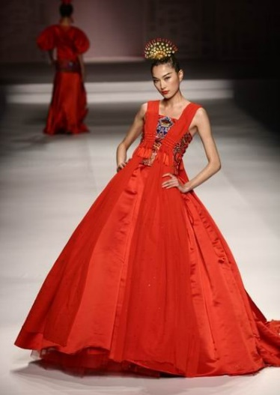
Figure 1. Wedding dress with a long skirt
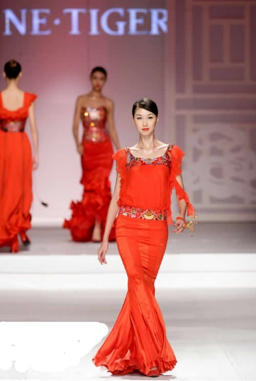
Figure 2. Wedding dress with a fishtail
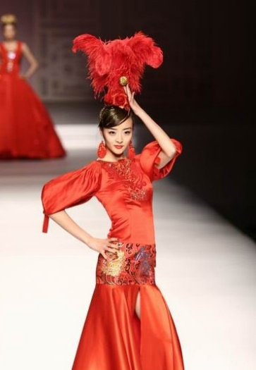
Figure 3. Wedding dress with puff sleeves

2.2 Innovative design of fabrics

With the development of science and technology, new fabrics have emerged one after another. Technologically processed cotton, linen, wool, chemical fiber fabrics and various furs, as well as nanofibers and bamboo carbon fibers rich in high-tech content can be used in wedding dresses. At the same time, we can change the traditional matching mode of wedding dress fabrics. Fabrics of different textures present different feelings, such as crisp, elegant, heavy, drooping, etc(Wang, 2011).
In addition to new fabrics, the use of modern wedding dresses also includes the secondary creation of fabrics. The techniques of re-creation of fabrics include layering, hollowing, splicing, and decoration. Layering refers to the use of folding, sewing, curling, superposition, accumulation, winding, pleating and other techniques on flat fabrics to increase the sense of layering and volume of fabrics. Hollowing refers to carving, tearing, drawing, and wearing on the original fabric. Splicing refers to stitching together fabrics of different colors and textures in the front or back, upside down or forward, to present different effects. Decoration refers to the use of printing and dyeing, embroidery, three-dimensional flower arrangement, beading, applique, painting and other techniques to process the original fabric. As shown in Figure 41, this is a work designed by Cai Meiyue. The skirt uses a lot of hollow designs. The overlapping of yarn makes the skirt richer and more layered. The tube top adds a three-dimensional decoration on the basis of the flat surface. As shown in Figure 42, the work uses embroidery, three-dimensional flower arrangement and beading and other decorative techniques.
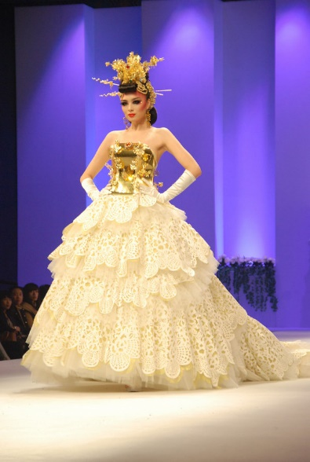
Figure 4. Wedding dress with hollow skirt
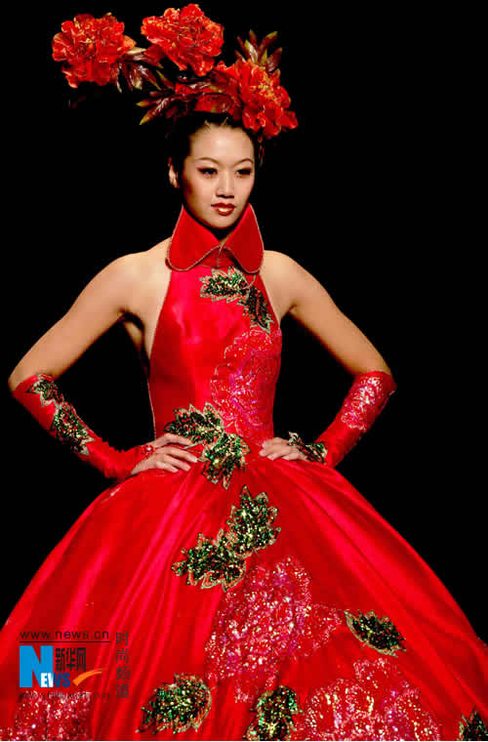
Figure 5. Modernhan wedding dress

2.3 Innovative design of patterns and colors

Clothing patterns are the pursuit of spiritual meaning and cultural taste. Therefore, for modern clothing, Chinese traditional patterns need to be simplified and fashionable, abandoning complicated styles and taking their meanings(Guo, 2002). The patterns used in traditional wedding clothing contain auspicious, happy, festive and other good meanings. These patterns are rich and colorful, with various images, including birds and beasts, seasonal flowers, geometric patterns, etc(Yuzhu., 2022). For thousands of years, patterns have always been associated with clothing, which shows how important patterns are. The innovative design and application of patterns can form a method that adapts to modern design language by breaking up, deconstructing and reorganizing traditional patterns, showing the meaning of the combination of traditional patterns and modern aesthetic consciousness.
Since ancient times, the colors of traditional Chinese clothing have been particular. The development of traditional Chinese wedding clothes to modern times is mostly based on "Chinese red", and red is a color of happiness, auspiciousness and festivity in China. At present, red and white are common in the wedding dress market in my country, which is related to the development process of wedding clothes in my country. As society develops, people's aesthetics are also developing. New people now like to express themselves and show their personality in colorful wedding clothes. Therefore, distinctive and diversified wedding dresses will also become a popular trend. As shown in Figure 6, modern traditional wedding dresses will also appear in green, blue, and yellow.
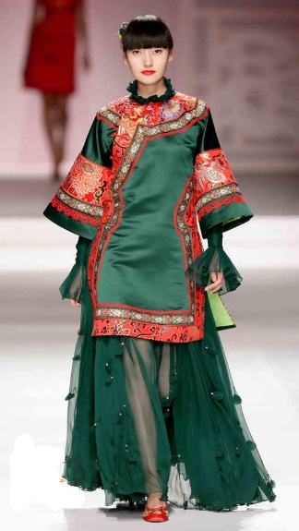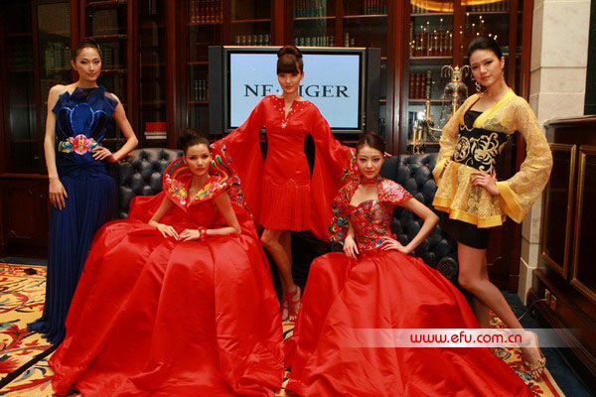
Figure 6. NE TIGER modern traditional wedding dress

In general, the color design of wedding dresses must be combined with other components such as shape, fabric, pattern, accessories, etc. to present a better effect.

INNOVATIVE DESIGN PRACTICE

This research contributes new knowledge by exploring the integration of music education with other academic disciplines in secondary schools. It delves into the Through the analysis of the historical evolution of Han wedding dresses, the innovative design methods of contemporary Han wedding dresses, and the development trend of contemporary wedding dresses, I have tried to carry out innovative design practices on modern Han wedding dresses. The following is an attempt at design practice.
Work title: "Glorious Tang Emperor".
Inspiration: The traditional dress style of the Han nationality in the Tang Dynasty, with women wearing classic elements such as bare breasts, high waist skirts, and long sleeves, while men wear Liangguan dresses and long robes and jackets; auspicious patterns include dragons and phoenixes, auspicious clouds, and peony patterns that were popular in the Tang Dynasty and symbolize wealth and auspiciousness, which are all the inspirations for my creation of this series. (See Figure 7).
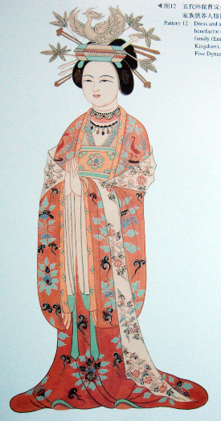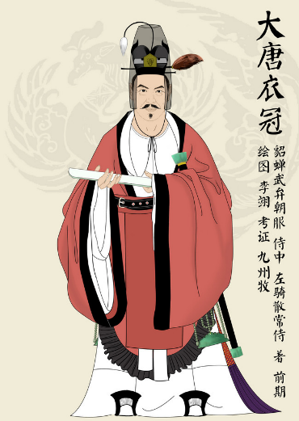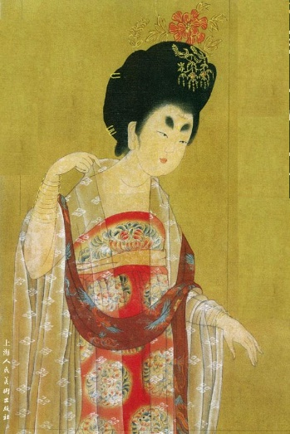
Figure 7. Tang Dynasty clothing style elements
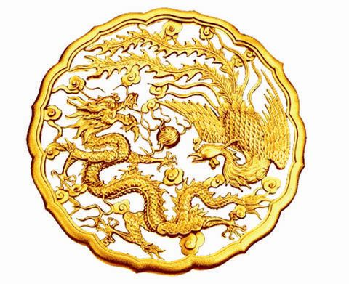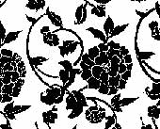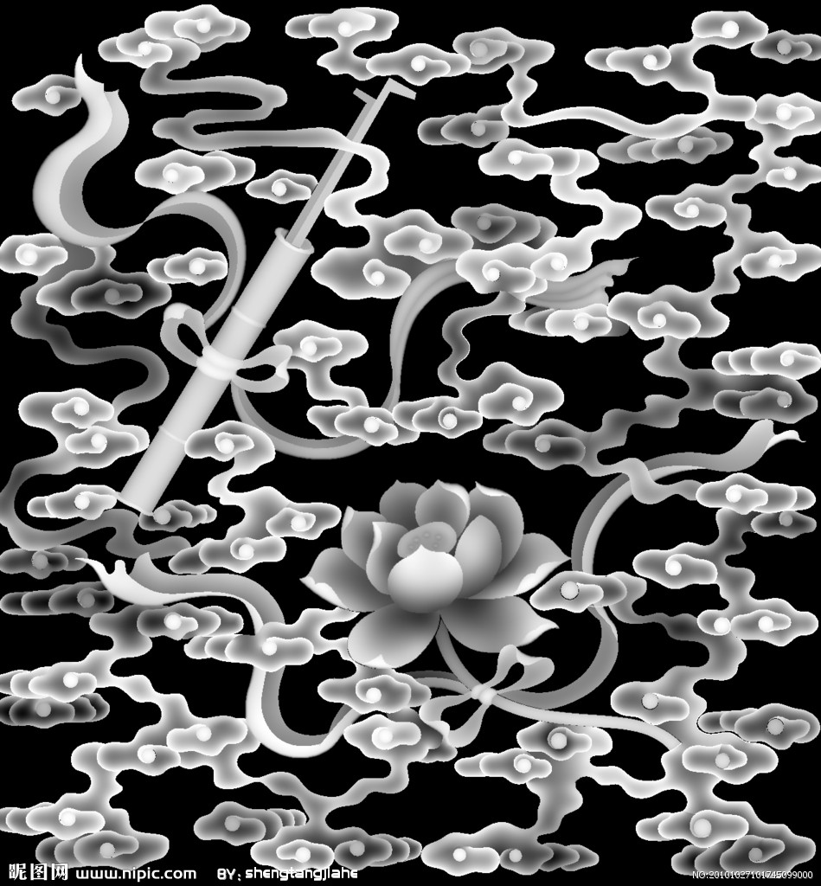
Figure 8. Tang Dynasty pattern elements

Design Notes: The four sets of works I designed are mainly in Chinese red, and the contrast of red levels with different textures and purity shows rich visual effects. The fabrics are satin, brocade, Korean yarn and chiffon, which cleverly combine traditional and modern elements. Brocade inherits the classic traditional style, while modern yarn injects lightness and modern atmosphere. The design combines single-line embroidery and coil embroidery techniques, making the fabric present richer layers and textures. In terms of modeling design, it combines Chinese and Western elements, retaining the traditional solemnity and implicitness, and incorporating modern fashion sense, reflecting the era characteristics of the works and the globalized clothing aesthetics. These designs not only show the profound cultural heritage of our country, but also highlight the charm of oriental aesthetics, bringing a solemn and festive atmosphere to the bride and groom. Through the meticulous contrast of red levels and the diverse use of fabrics, each work exudes a unique brilliance, which not only meets the aesthetic requirements of modern people for wedding costumes, but also conveys the cherishment and respect for traditional craftsmanship.
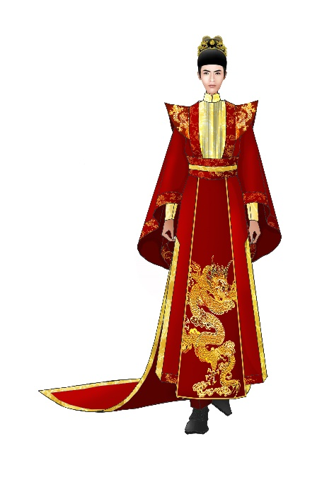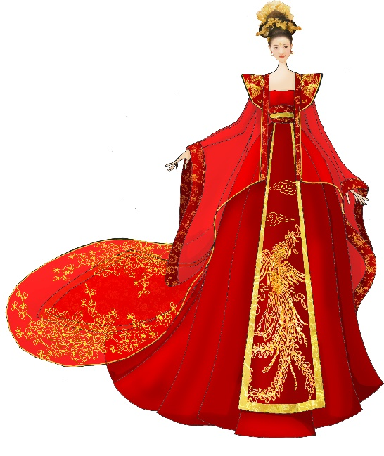
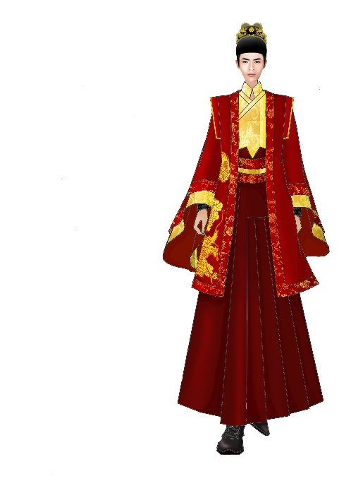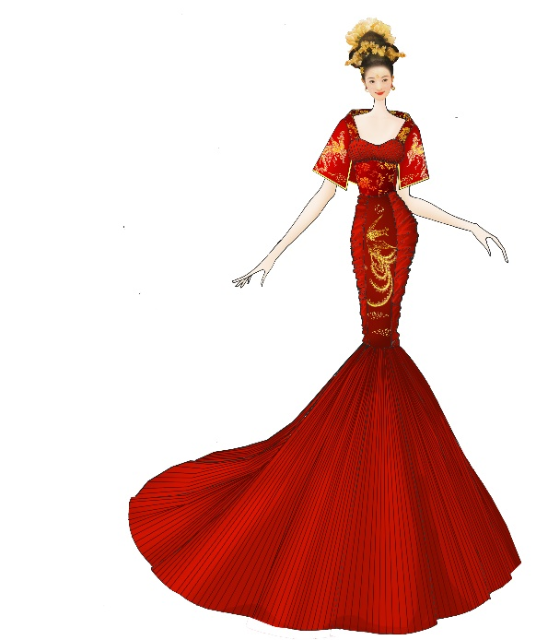
Figure 9. My design works clothing painting renderings
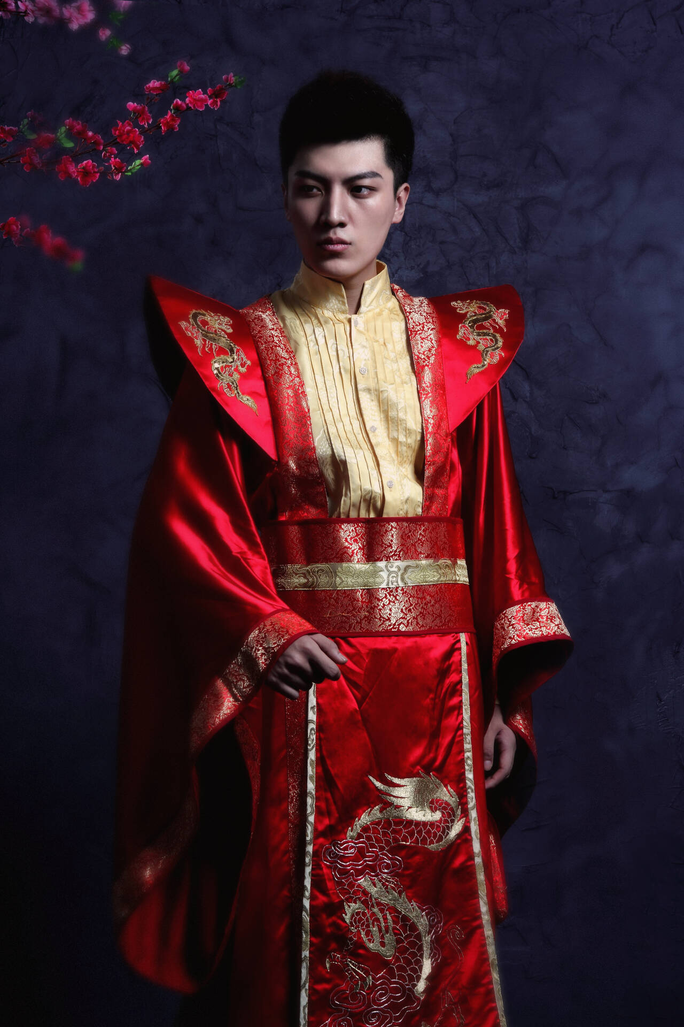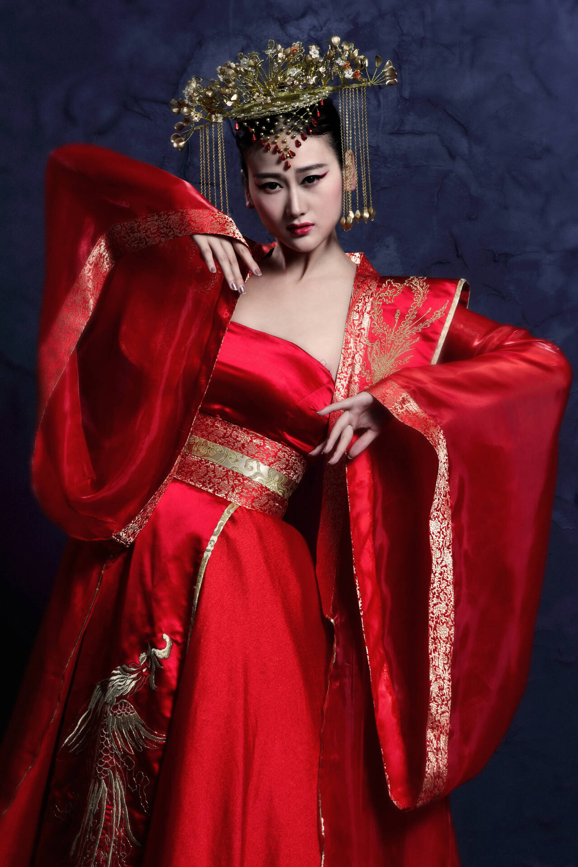
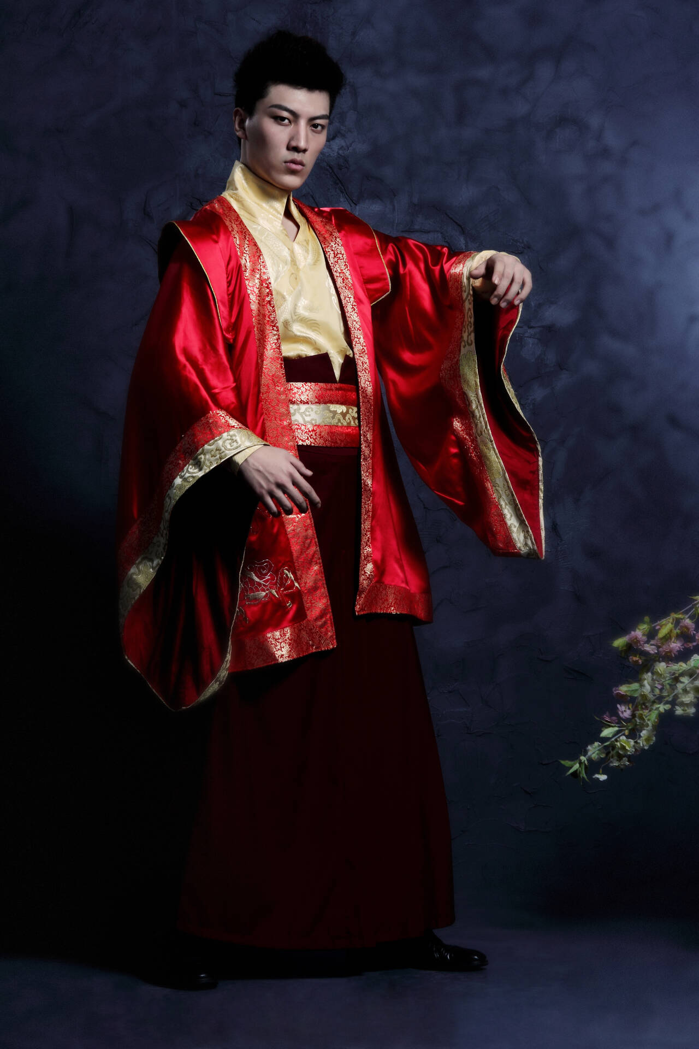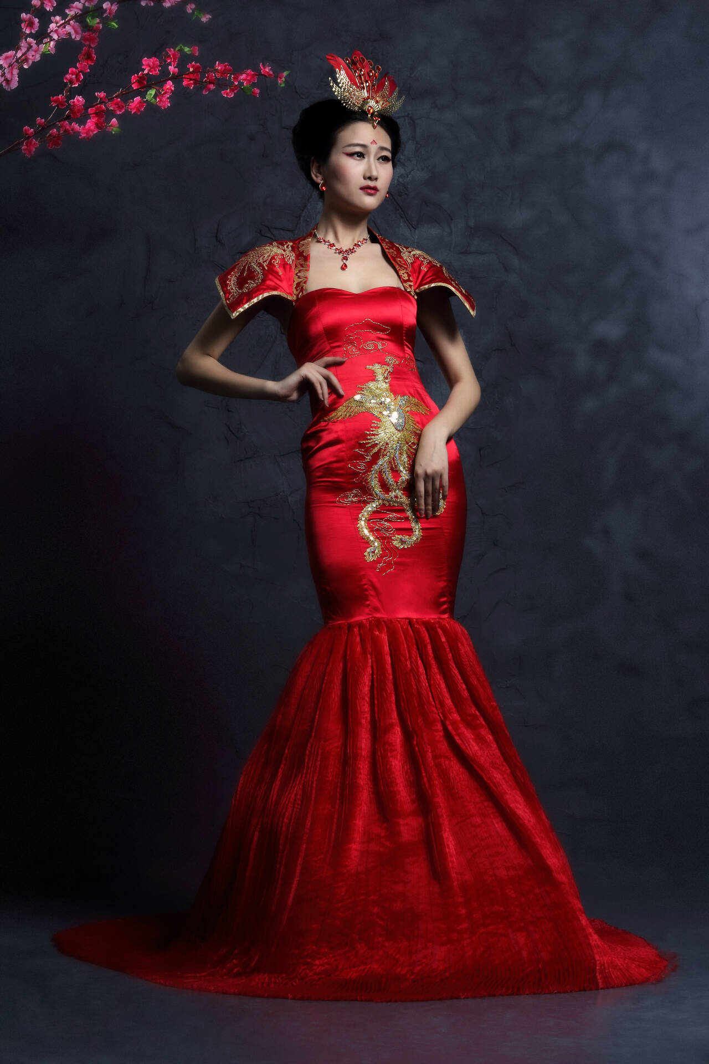
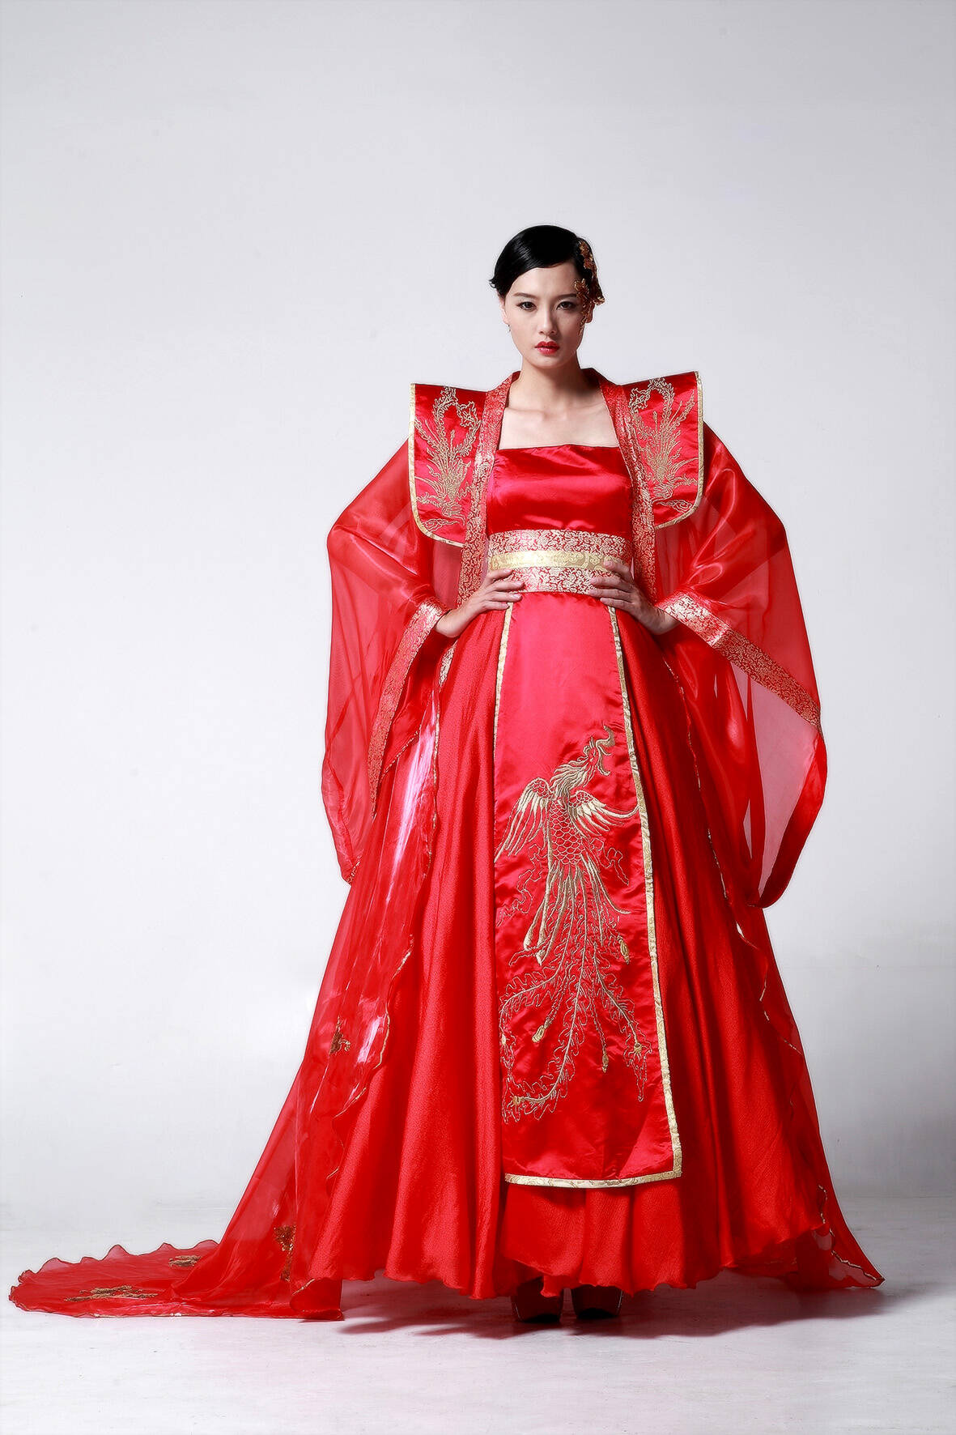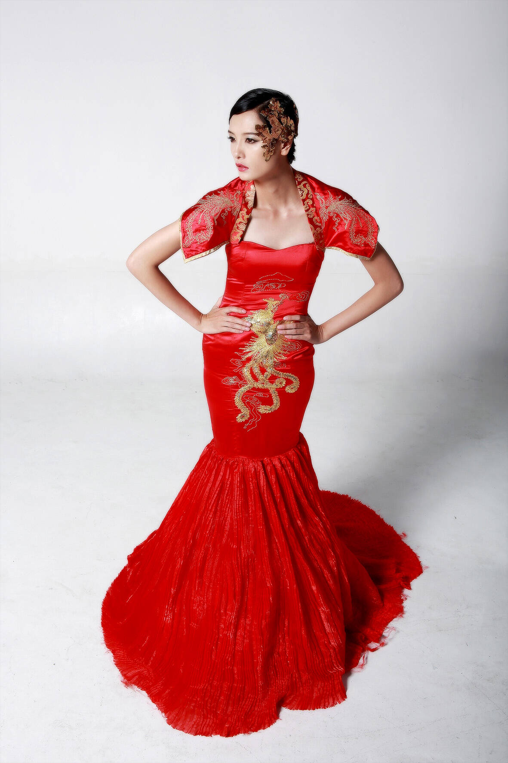
Figure 10. Photos of my designs

CONCIUSION

In the wedding dress market today, my country's wedding dress industry is growing and developing. Han wedding dresses are representatives of traditional clothing. They are characterized by national design, which is the core of competition and the trend of modern wedding dress development. This will surely usher in greater development opportunities. Therefore, it is very necessary and meaningful to choose wedding dresses as the research object. The design points of modern Han wedding dresses include shape, fabric, pattern, color, craftsmanship and other aspects. Innovation is the unchanging pursuit of design. This paper analyzes the development status of traditional wedding dresses in the past dynasties and the modern and contemporary influences of the West, and combines the reference and practice of some Han wedding dress brands that have appeared at home and abroad. From the perspectives of wedding dress design, the innovative design exploration draws a conclusion: in terms of shape, the advantages of Eastern and Western wedding dresses can be combined, and the available elements can be used for innovative design. Fabric innovation design can adopt secondary fabric transformation. On the basis of the original fabric, a variety of means can be used to change the original texture of the fabric, and the three-dimensional effect can be appropriately added. At the same time, innovative fabrics can be boldly used to make it better match the innovative design of modern wedding dresses. The innovation of traditional auspicious patterns should be combined with modern craftsmanship to create a more fashionable visual effect. During the design process, we actively explore and digest national traditional elements, strive to bring forth new ideas and keep the essence, and the innovative design of wedding dresses reaches a higher level of "spiritual resemblance", and reasonably integrates Chinese and Western cultures, so that our wedding dresses have both traditional charm and contemporary flavor.
In general, diversification, personalization, nationalization, technology, and high-end are the development trends of modern wedding dresses. Wedding dresses are clothes with special meanings, and the design of wedding dresses cannot be separated from the market's test of them. Only the language style that is suitable for the popular trend of contemporary wedding dresses can occupy a place in the wedding dress market.

REFERENCES

Dai, Q. (1998). Ancient Chinese Clothing.
Fang, L. (2019). Research and innovative design of traditional wedding costumes for Han women during the Republic of China period Beijing Institute of Fashion Technology].
Feng Zemin, Q. Z. (2001). A Course on the History of Clothing Development.
Gao, G. (2005). A detailed discussion of Chinese clothing.
Guo, X. (2002). Chinese Traditional Marriage Customs.
Hongfang, H. Y. W. (2010). A study on the national characteristics of wedding dress decoration techniques in the context of globalization. Journal of Suzhou University, 1.
Hua, M. (2000). Clothing Feelings.
Huang, D. (2012). Traditional graphics and modern dress design. Art Education 12.
Jun., W. G. P. (2006). Study on Chinese and Western Wedding Costume Culture. Beauty and Times 12.
Muhua, X. (2021). A Study on Wedding Costumes of Han Chinese Women in Modern China Suzhou University].
Qi, C. (2011a). A brief discussion on the future of Han ethnic wedding dresses. Shandong Textile Economy, 11.
Qi, C. (2011b). On the future of Han ethnic wedding dresses. 11, 56-58.
Qiu, Z. (2014). A brief discussion on the influence of Chinese traditional clothing culture on modern wedding dresses. Popular Literature and Art, 24.
Shen, C. (2011). Research on Ancient Chinese Clothing.
Shen, X. (2006). The development trend of "wedding dresses" in the new era: starting from the "wedding dresses and wedding gowns" at the fashion week. Textile and Clothing Weekly, 45.
Wang, F. (2012). Comparison of Chinese women's wedding dresses from ancient times to the present. Beauty and Times (Part 1), 8.
Wang, L. (2011). From the perspective of Hanfu style to the inheritance and application of national culture in modern clothing design. Tianjin Textile Science and Technology, 2.
Yang, H. (2006). New Style of Wedding and Funeral in Modern China.
Yuzhu., Y. J. Z. N. Z. (2022). Analysis of the characteristics of women's wedding dresses in the Republic of China from 1912 to 1936. Fashion Guide, 3.
Zhao, L. (2007). Illustrated Dictionary of Ancient Chinese Costumes.

