only (not all words), Please type: do not copy & paste

(17 pt blank line)

First Author1*, Second Author2, Second Author3  
(Please type author/s name here)

(13 pt blank line)

*1First affiliation, City and Country*

*2Second affiliation, City and Country*

*3Second affiliation, City and Country*

(9 pt blank line)

*\* Corresponding author e-mail:* [*youremailhere@email.com*](mailto:donottypehere@email.com)

(9 pt blank line)

|  |  |  |
| --- | --- | --- |
| ARTICLE INFO |  | ABSTRACT |
| *Article history:*  Received  Accepted  Published |  | The abstract word count should not be more than 300 words. Please format your abstract using the ‘Abstract’ style in the style gallery.  The **line numbers** on the left allow easier referencing and communication between the author and reviewers during double-blind peer review. Please **do not remove** the line numbers.  An abstract should stand alone, which means that no citation in the abstract. Consider it the advertisement for your article. The abstract should tell the prospective reader what you did and highlight the key findings. Avoid using technical jargon and uncommon abbreviations. You must be accurate, brief, clear, and specific. Use words that reflect the precise meaning. The abstract should be precise and honest. Keywords are the labels of your manuscript and critical to correct indexing and searching. Therefore, the keywords should represent the content and highlight of your article. Use only those abbreviations that are firmly established in the field.  Please **do not edit or remove** any texts or objects highlighted in red color.  Please **read the content of this guideline entirely**. Failure to adhere to this guideline shall lead to manuscript rejection at the desk evaluation stage. |
| *Keywords:*  Keyword1  Keyword2  Keyword3  Keyword4  *DOI*  [10.24191//jibe](https://journal.uitm.edu.my/ojs/index.php/JIBE/index) |  |

1. **Insert your heading here (do not copy paste)**

(10 pt) The paragraphs continue from here and are only separated by headings, subheadings, images and formulae. The section headings are arranged by numbers, bold and 10 pt. Here are further instructions for authors.

* 1. *Structure*

Files should be in MS Word format only and should be formatted for direct printing. Figures and tables should be embedded and not supplied separately. Please make sure that you use as much as possible normal fonts in your documents. Special fonts, such as fonts used in the Far East (Japanese, Chinese, Korean, etc.) may cause problems during processing. To avoid unnecessary error, you are strongly advised to use the ‘spellchecker’ function of MS Word. Follow this order when typing manuscripts: Title, Authors, Affiliations, Abstract, Keywords, Main text (including figures and tables), Acknowledgements, References, Appendix. Collate acknowledgements in a separate section at the end of the article and do not include them on the title page, as a footnote to the title or otherwise.

Bulleted lists may be included and should look like this:

* First point
* Second point
* And, so on

Ensure that you return to the ‘Main Text’ style, the style that you will mainly be using for large blocks of text, when you have completed your bulleted list.

Please do not alter the formatting and style layouts which have been set up in this template document. As indicated in the template, papers should be prepared in single column format. Do not number pages on the front, as page numbers will be added separately for the preprints and the Proceedings. Leave a line clear between paragraphs. All the required style templates are provided in this document with the appropriate name supplied. **Please refer to page 7 for complete guide on styles.**

* 1. *Tables*

All tables should be numbered with Arabic numerals. Headings should be placed above tables, left justified. Leave one line space between the heading and the table. Only horizontal lines should be used within a table, to distinguish the column headings from the body of the table, and immediately above and below the table. Tables must be embedded into the text and not supplied separately. Below is an example which authors may find useful.

|  |  |  |
| --- | --- | --- |
| An example of a column heading | Column A (*t*) | Column B (*T*) |
| And an entry | 1 | 2 |
| And another entry | 3 | 4 |
| And another entry | 5 | 6 |

Table 1. An example of a table (Font = 8; Click ‘Caption A’ on the Styles Gallery)

* 1. *Construction of references*

References should be listed at the end of the paper, should be arranged first alphabetically and then further sorted chronologically if necessary. More than one reference from the same author(s) in the same year must be identified by the letters “a”, “b”, “c”, etc., placed after the year of publication.

Some examples of how your references should be listed are given at the end of this template in the ‘References’ section which will allow you to assemble your reference list according to the correct format and font size.

* 1. *Section headings*

Section headings should be left justified, with the first letter capitalized and numbered consecutively, starting with the Introduction. Sub-section headings should be in capital and lower-case italic letters, numbered 1.1, 1.2, etc, and left justified, with second and subsequent lines indented. You may need to insert a page break to keep a heading with its text.

* 1. *General guidelines for the preparation of your text*

Avoid hyphenation at the end of a line. Symbols denoting vectors and matrices should be indicated in bold type. Scalar variable names should normally be expressed using italics. Weights and measures should be expressed in SI units. Please title your files in this order firstauthorname.docx.

* 1. *Footnotes*

Footnotes should be avoided if possible. Necessary footnotes should be denoted in the text by consecutive superscript letters. The footnotes should be typed single spaced, and in smaller type size (8pt), at the foot of the page in which they are mentioned, and separated from the main text by a short line extending at the foot of the column. The ‘footnote’ style is available in this template for the text of the footnote.

* 1. *Referencing and citation style*

The manuscript’s references and citations should be written using the APA 7th edition style. In terms of the in-text citation style, APA uses the author's last name and the year of publication, for example: (Field, 2005); (Field & Thomas; 2014). If there are three or more authors, cite only the surname of the first author followed by “et al.” and the year., for example: (Field et al., 2017). For direct quotations, include the page number as well, for example: (Field, 2005, p. 14).

The sample of references is available on page 5. Please refer to the following website for further details on APA 7th edition referencing style: https://libraryguides.vu.edu.au/apa-referencing

1. **Author artwork**

All figures should be numbered with Arabic numerals (1,2,...n). All photographs, schemas, graphs and diagrams are to be referred to as figures. Line drawings should be good quality scans or true electronic output. Low-quality scans are not acceptable. Figures must be both embedded into the text and all images should met the minimum requirement of 500 x 500 pixels. Lettering and symbols should be clearly defined either in the caption or in a legend provided as part of the figure. Figures should be placed at the top or bottom of a page wherever possible, as close as possible to the first reference to them in the paper.

* 1. *Diagrams*

Diagrams can be in the form of framework, process flow, chart, or any visual aids that are meant to support the written text. Any diagrams built using Microsoft Word or Powerpoint’s Smart Art Graphic Tool needs to be embedded as editable or vector-based objects (instead of image objects). Diagrams attached using bitmap-based images (jpeg., png., and other formats) need to be in high resolution (at least 300 pixels per inch).

* + 1. *Texts embedded in diagrams*

The font used for labels or indicators inside the diagram needs to be formatted as Times New Roman with font size set at 9. It must not be bold, italized or underlined.

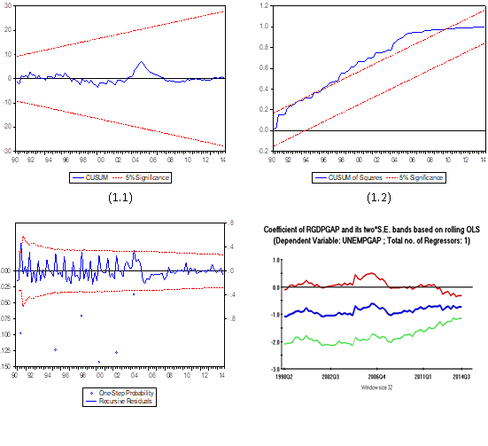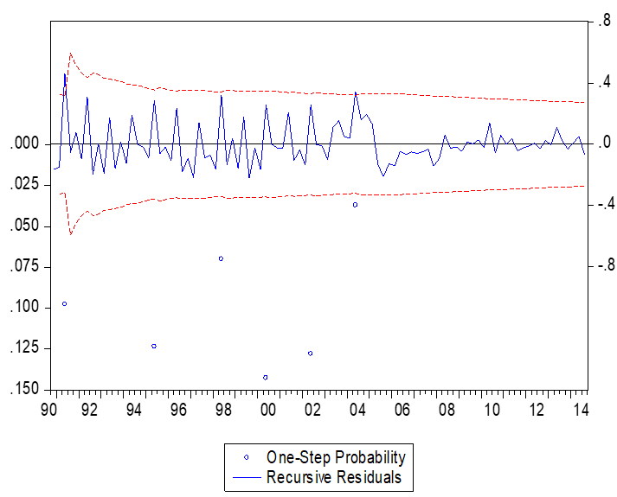

Figure 1. (left) this figure is blurry, which is unacceptable; (right) this figure has a higher resolution. However, the labels are not formatted using Times New Roman font. (Font = 9; Click ‘Caption B’ on the Styles Gallery)

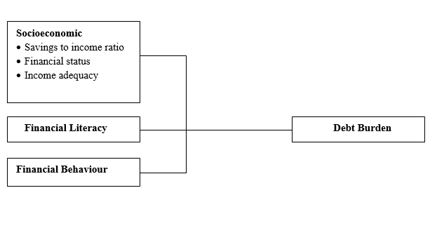

**Socio-economic factors**

Savings to income ratio

Financial status

Income adequacy

**Financial literacy**

**Financial behaviour**

**Debt burden**

Figure 2. (left) this framework is a non-editable diagram, appears blurry and hence, is unacceptable;   
(right) this framework is built using Ms Word illustration tools, has higher resolution and is acceptable.   
(Font = 9; Click ‘Caption B’ on the Styles Gallery)

Please use the ‘drawing canvas tool’ in Ms Word before inserting any images or diagrams into the document. When constructing a conceptual/theoretical framework, please use editable or vector-based diagrams. Draw diagrams using Ms Word’s Smart Art Graphic Tool (textboxes, labels, arrows, legends, etc.) rather than embedding non-editable image objects. Ensure that all the figures have a good resolution (minimum 300dpi) and are not fuzzy or blurry.

* 1. *Captions*

The figure number and caption should be typed below the illustration in 9pt and left justified. Artwork has no text along the side of it in the main body of the text. However, if two images fit next to each other, these may be placed next to each other to save space, see Fig 1. They must be numbered consecutively, all figures, and all tables respectively.

1. **Equations and formulas**

Equations and formulae should be typed and numbered consecutively with Arabic numerals in parentheses on the right hand side of the page (if referred to explicitly in the text). They should also be separated from the surrounding text by one space. If you chose to use the Equation Editor, please ensure that the manuscript is saved using .docx format (rather than .doc), and Compatibility Mode is turned off.

|  |  |  |
| --- | --- | --- |
|  | *Rt = K EP = 93.02 (±9.62) – 13.45* | *(1)* |

**Acknowledgements**

This section is compulsory. The following is an example of an acknowledgement statement:

The authors would like to acknowledge the support of Universiti Teknologi MARA (UiTM), Cawangan Negeri Sembilan, Kampus Kuala Pilah and Faculty of Applied Sciences, Universiti Teknologi MARA, Shah Alam, Selangor, Malaysia for providing the facilities and financial support on this research.

**Conflict of interest statement**

This section is compulsory. The following is an example of a conflict-of-interest statement:

The authors agree that this research was conducted in the absence of any self-benefits, commercial or financial conflicts and declare the absence of conflicting interests with the funders.

**References**

Please ensure that every reference cited in the text is also present in the reference list (and vice versa).

Authors are also required to cite at least **TWO (2)** articles that were published in the Journal of International Business, Economics and Entrepreneurship (JIBE).

*Chapters in book*

Mettam, G. R., & Adams, L. B. (1994). How to prepare an electronic version of your article. In B. S. Jones, & R. Z. Smith (Eds.), *Introduction to the electronic age* (pp. 281-304). E-Publishing Inc.

*Book*

Barras, R. (2002). *Scientists must write: A guide to better writing for scientists, engineers and students* (2nd ed.). Routledge.

*Journal article*

Abdul Ghofur, R., Madnasir, Anggraini, E., Nurlaili, & Mohd Abas, M. K. (2023). Optimisation of Waqf Contribution Awareness among Indonesian Workers Through Digital System. *Journal of International Business, Economics and Entrepreneurship*, *8*(2), 1–6. <https://doi.org/10.24191/jibe.v8i2.24610>

Anggraini, F., & Purnama, A. I. (2024). ICT and Entrepreneurial Orientation as Drivers of SME Performance: Insights from Padang Pariaman Regency, Indonesia. *Journal of International Business, Economics and Entrepreneurship*, *9*(2), 75–91. <https://doi.org/10.24191//jibe.v9i2.2417>

*Conference proceedings*

Dusuki, A. W. & Dar, H. (2007). Stakeholder's perceptions of corporate social responsibility of Islamic banks: Evidence from Malaysian economy*.* In M. Iqbal, S. S. Ali & D. Muljawan (Eds.), *Proceedings of the 6th International Conference on Islamic Economics and Finance* (pp. 249-277). Jeddah, Saudi Arabia: Islamic Development Bank.

*Note: Please refer to this website for more examples on APA (7th edition) referencing: https://libraryguides.vu.edu.au/apa-referencing*

**An example appendix**

Authors including an appendix section should do so after References section. Multiple appendices should all have headings in the style used above. They will automatically be ordered A, B, C etc.

1. *Example of a heading within an appendix*
   1. *Example of a sub-heading within an appendix*

There is also the option to include a subheading within the Appendix if you wish.

**About the Authors**

Please submit another separate file by naming it as “Author Information”. Avoid revealing the identity and information of the authors in the manuscript (that should be anonymous). Provide the following information in the separated file.

*Author 1 (Full Name, without Titles/Designation)*, Please summarize the academic background and details of the author, and contact information (an e-mail address is compulsory for the corresponding author). Please also include your 12-digit Orcid ID (visit <http://orcid.org> to register). The authors’ biographical information will be displayed after the Reference List. Maximum number of words is 100.

*Author 2 (Full Name, without Titles/Designation)*, Please summarize the academic background and details of the author, and contact information (an e-mail address is compulsory for the corresponding author). Please also include your 12-digit Orcid ID (visit <http://orcid.org> to register). The authors’ biographical information will be displayed after the Reference List. Maximum number of words is 100.

*EXAMPLE:   
Danial Rashid, PhD* is Associate Professor in the Department of Management and Finance at the University of Malaysia (ORCID: http://orcid.org/0000-0000-0000-0000). His main research activity is in the area of organizational innovation and organizational learning. He has published widely on these subjects in publications such as the *International Journal of HRM, Journal of Business Research*, *International Journal of Information Management and Management Decision*. His can be reached through his email at [danialrashid@university.edu](mailto:danialrashid@university.edu).

**Authors’ contributions**

This section is compulsory. Please submit this information in another separate file by naming it as “Author Information”. Each author contribution must be stated clearly reflecting each contribution to the body of the work and manuscript. There are fourteen types of author contributions. Some of these contributions (if not all) need to be specified and attributed to each of the author(s).

* Conceptualization
* Data collection
* Formal Analysis
* Funding acquisition
* Investigation
* Methodology
* Project administration
* Resources
* Software
* Supervision
* Validation
* Visualization
* Writing – original draft
* Writing – review & editing

For example:

Jaya Subramaniam carried out the research, wrote and revised the article. Rahmah Hassan conceptualised the central research idea and provided the theoretical framework. Both Rahmah Hassan and Chong Ju Lian designed the research, and supervised research progress. Rahmah Hassan anchored the review, revisions and approved the article submission.

|  |  |
| --- | --- |
|  | © 202025 by the authors. Submitted for possible open access publication under the terms and conditions of the Creative Commons Attribution (CC BY-NC-SA) license (https://creativecommons.org/licenses/by-nc-sa/4.0/deed.en). |

*Note: Please include the above copyright disclaimer and logo in your manuscript.*

**Specific Instructions**

The manuscripts must be composed of the following scientific article components (subtitles-in order), as follows:

**Article Title**: Identify the main issue of the article. Begin with the subject of the article. The title should be accurate, unambiguous, specific, and complete. Do not contain infrequently-used abbreviations.

**Authors Name and Affiliations**: Write Author(s) names without a title and professional positions such as Prof, Dr, Production Manager, etc. Do not abbreviate your last/family name. Always give your First and Last names. Write clear affiliation of all Authors. Affiliation includes the name of department/unit (or faculty), the university's name or institution, address, country. Please indicate Corresponding Author (include email address) by adding an asterisk (*) in superscript behind the name.

**Abstract and Keywords**: An abstract should stand alone, which means that no citation in the abstract. Consider it the advertisement for your article. The abstract should tell the prospective reader what you did and highlight the key findings. Avoid using technical jargon and uncommon abbreviations. You must be accurate, brief, clear, and specific. Use words that reflect the precise meaning. The abstract should be precise and honest. Please follow the word limitations (150‐300 words). Keywords are the labels of your manuscript and critical to correct indexing and searching. Therefore, the keywords should represent the content and highlight of your article.

**Introduction**: In the Introduction, the Authors should state the work's objectives at the end of the introduction section. Before the objective, the Authors should provide an adequate background and concise literature survey to record the existing solutions/method, to show which is the best of previous research, to show the main limitation of the previous research, to show what do you hope to achieve (to solve the limitation) and to show the scientific merit or novelties of the paper. Avoid a detailed literature survey or a summary of the results. Do not describe the literature survey as author by author, but should be presented as the group per method or topic reviewed, which refers to some literature. Example of novelty statement or the gap analysis statement at the end of the Introduction section (after the state of the art of previous research survey): “*........ (short summary of background)....... A few researchers focused on ....... There have been limited studies concerned on ........ Therefore, this research intends to ................. The objectives of this research are .........*”.

**Research Methods**: The research method describes the stages of research/development undertaken to achieve the research's objectives/outputs.  Each stage is briefly described (e.g., each step in a paragraph). Also, inform the materials/platforms used in the study, including the subjects/materials, the tools/software used, the design or experiment used, the sampling technique, the test plan (the variable to be measured and the data retrieval technique), analysis and statistical model used.

**Results and Discussion**: Results should be clear and concise. The results should summarize (scientific) findings rather than providing data in great detail. Please highlight the differences between your results or findings and the previous publications by other researchers. The discussion should explore the significance of the results of the work, not repeat them. Combined results and their discussion paragraph is often appropriate. Avoid extensive citations and discussion of published literature. In the discussion, it is the most important section of your article. Here you get the chance to sell your data. Make the discussion corresponding to the results, but do not reiterate the results. Often should begin with a brief summary of the main scientific findings (not experimental results). The following components should be covered in the discussion: How do your results relate to the original question or objectives outlined in the Introduction section (what/how)? Do you provide interpretation scientifically for each of your results or findings presented (why)? Are your results consistent with what other investigators have reported (what else)? Or are there any differences.

**Conclusion**: The conclusion should answer the objectives of the research. Tells how your work advances the field from the present state of knowledge. Without clear Conclusions, reviewers and readers will find it difficult to judge the work and whether it merits publication in the journal. Do not repeat the Abstract or list experimental results. Provide a clear scientific justification for your work, and indicate possible applications and extensions. It would help if you also suggested future experiments and/or point out those that are underway.

**Acknowledgements:** This section is compulsory. The following is an example of an acknowledgement statement:

The authors would like to acknowledge the support of Universiti Teknologi MARA (UiTM), Cawangan Negeri Sembilan, Kampus Kuala Pilah and Faculty of Applied Sciences, Universiti Teknologi MARA, Shah Alam, Selangor, Malaysia for providing the facilities and financial support on this research.

**Conflict of interest statement:**

This section is compulsory. The following is an example of a conflict-of-interest statement:

The authors agree that this research was conducted in the absence of any self-benefits, commercial or financial conflicts and declare the absence of conflicting interests with the funders.

**References**: All references referred to in the article text must be listed in the References section. The references shall contain at least **15 (fifteen) references** from primary sources (scientific journals, conference proceedings, research reference books) or 80 % of total references, which are published within *5 (five)* years.  The citation format and the references must follow the **APA 7.0 Style format**.

**Style Formatting: Special Instruction to Authors (Please read this)**

* Authors are required to edit the template using Microsoft Word 2010 onwards.
* Authors must use the ‘Styles Gallery’ to format the written contents of the article.
* The Styles Gallery is located within the Home Ribbon, in the Styles Pane.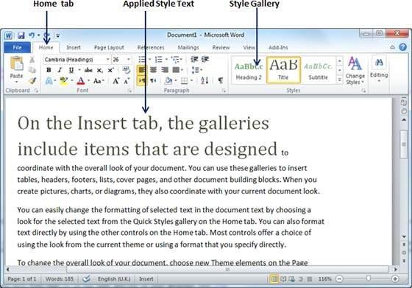
* The ‘Styles Gallery’ appears as follows:
* Please utilize the Styles Gallery when formatting your article.
* Please avoid doing the following:
  + adjust the paragraph parameters
  + add numbering to headings
  + increase or decrease indentation
  + create new headings
* 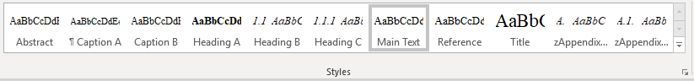If the formatting appears to stray away from the requirements, select the affected paragraphs/headings, and click the “Clear Formatting” icon at the ‘Font’ section of the ‘Home’ ribbon. 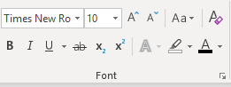
* The formatting will be reset. Again, apply the intended formatting by clicking the specific style using the Styles Gallery.

Please refer to the table below to understand the target use of each of the specific style.

|  |  |
| --- | --- |
| **Style Name** | **Targeted Use** |
| Title | Main title |
| Author | Authors’ names *\*corresponding author’s details are located at the footnote section of the first page* |
| Affiliation | Author’s institutional affiliation |
| Footnote | Corresponding author’s e-mail address (use institutional e-mail address instead of free e-mail such as gmail, yahoo etc.) |
| Heading A | Main header with numbering (1,2,3…) |
| Heading B | Second level header (e.g. 1.1, 1.2, …) |
| Heading C | Third level header (e.g. 2.2.1, 2.2.2, …) |
| Main Text | The write-up of the article |
| Caption A | Caption for Table |
| Caption B | Caption for Figure |
| Reference | Bibliographic reference with indentation |
| zAppendix Heading 1 | Appendix header with lettering (A. B, C …) |
| zAppendix Heading 2 | Appendix second-level header with alphanumeric coding (e.g. B1. B2, B3 …) |

* If you successfully adhere to this instruction, your article will be generated into a bookmarked PDF that is easy to be navigated by readers.

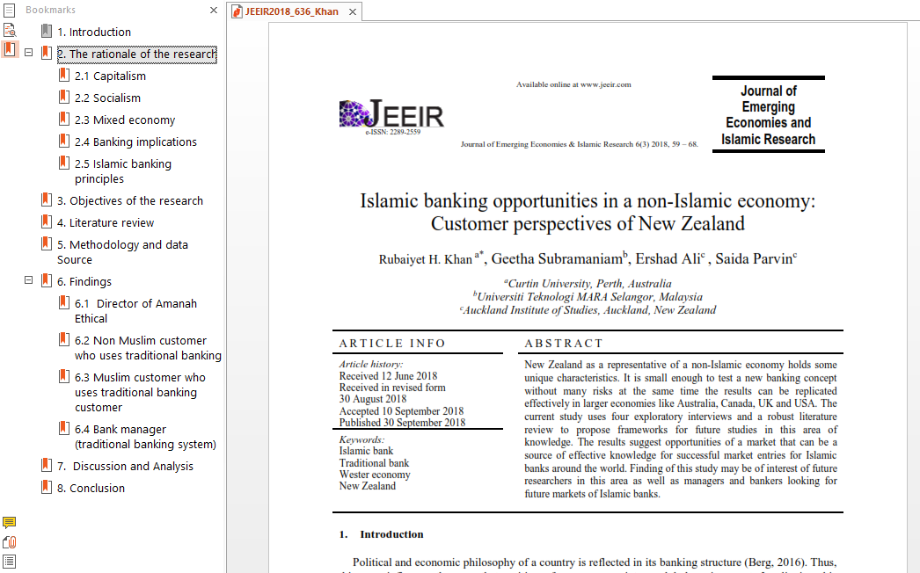

* This journal is a double-blind peer-reviewed open access journal that does not charge any publication fees. The journal is managed by volunteering academics of UiTM whose responsibilities include teaching, research, supervision, administration, and other academic obligations. Hence, your adherence to this guideline when submitting your manuscript is highly appreciated.

*Prepared by:*

*Muhammad Iskandar Hamzah, Ph.D.*

*Universiti Teknologi MARA (UiTM), Malaysia*

*February 2022*