only (not all words), Please type: do not copy & paste
(17 pt blank line)
First Author^{1*}, Second Author², Second Author³
(13 pt blank line)
¹First affiliation, City and Country
²Second affiliation, City and Country
³Second affiliation, City and Country
(9 pt blank line)
* Corresponding author e-mail: youremailhere@email.com
(9 pt blank line)
ARTICLE INFO |  | ABSTRACT
Article history:  Received  Accepted  Publish |  | Please format your abstract using the ‘Abstract’ style in the style gallery.  An abstract of maximum 300 words is required for any submitted manuscript. It is written narratively containing at least the aim(s), method, the theory used, conclusion, and the result(s) of the research. It should be self-contained and must be citation-free. It should not contain any undefined abbreviations or unspecified references.  The line numbers on the left allow easier referencing and communication between the author and reviewers during double-blind peer review. Please do not remove the line numbers.  Please do not edit or remove any texts or objects highlighted in red colour.  Please read the content of this guideline entirely. Failure to adhere to this guideline shall lead to manuscript rejection at the desk evaluation stage.
`Keywords:
Keyword 1
Keyword 2
Keyword 3
Keyword 4

DOI
https://doi.org/10.24191/jibe.vxxix.xxxx

- Insert your heading here (do not copy paste)

(10 pt) The paragraphs continue from here and are only separated by headings, subheadings, images and formulae. The section headings are arranged by numbers, bold and 10 pt. Here are further instructions for authors.

  - Structure

Files should be in MS Word format only and should be formatted for direct printing. Figures and tables should be embedded and not supplied separately. Please make sure that you use as much as possible normal fonts in your documents. Special fonts, such as fonts used in the Far East (Japanese, Chinese, Korean, etc.) may cause problems during processing. To avoid unnecessary error, you are strongly advised to use the ‘spellchecker’ function of MS Word. Follow this order when typing manuscripts: Title, Authors, Affiliations, Abstract, Keywords, Main text (including figures and tables), Acknowledgements, References, Appendix. Collate acknowledgements in a separate section at the end of the article and do not include them on the title page, as a footnote to the title or otherwise.
Bulleted lists may be included and should look like this:
- First point
- Second point
- And, so on
Ensure that you return to the ‘Main Text’ style, the style that you will mainly be using for large blocks of text, when you have completed your bulleted list.
Please do not alter the formatting and style layouts which have been set up in this template document. As indicated in the template, papers should be prepared in single column format. Do not number pages on the front, as page numbers will be added separately for the preprints and the Proceedings. Leave a line clear between paragraphs. All the required style templates are provided in this document with the appropriate name supplied. Please refer to page 7 for complete guide on styles.

  - Tables

All tables should be numbered with Arabic numerals. Headings should be placed above tables, left justified. Leave one line space between the heading and the table. Only horizontal lines should be used within a table, to distinguish the column headings from the body of the table, and immediately above and below the table. Tables must be embedded into the text and not supplied separately. Below is an example which authors may find useful.

Table 1. An example of a table (Font = 10; Click ‘Caption A’ on the Styles Gallery)

An example of a column heading | Column A (t) | Column B (T)
And an entry | 1 | 2
And another entry | 3 | 4
And another entry | 5 | 6

  - Construction of references

References should be listed at the end of the paper, should be arranged first alphabetically and then further sorted chronologically if necessary. More than one reference from the same author(s) in the same year must be identified by the letters “a”, “b”, “c”, etc., placed after the year of publication.

Some examples of how your references should be listed are given at the end of this template in the ‘References’ section which will allow you to assemble your reference list according to the correct format and font size.

  - Section headings

Section headings should be left justified, with the first letter capitalized and numbered consecutively, starting with the Introduction. Sub-section headings should be in capital and lower-case italic letters, numbered 1.1, 1.2, etc, and left justified, with second and subsequent lines indented. You may need to insert a page break to keep a heading with its text.

  - General guidelines for the preparation of your text

Avoid hyphenation at the end of a line. Symbols denoting vectors and matrices should be indicated in bold type. Scalar variable names should normally be expressed using italics. Weights and measures should be expressed in SI units. Please title your files in this order firstauthorname.docx.

  - Footnotes

Footnotes should be avoided if possible. Necessary footnotes should be denoted in the text by consecutive superscript letters. The footnotes should be typed single spaced, and in smaller type size (8pt), at the foot of the page in which they are mentioned, and separated from the main text by a short line extending at the foot of the column. The ‘footnote’ style is available in this template for the text of the footnote.

  - Referencing and citation style

The manuscript’s references and citations should be written using the APA 7th edition style. In terms of the in-text citation style, APA uses the author's last name and the year of publication, for example: (Field, 2005); (Field & Thomas; 2014). If there are three or more authors, cite only the surname of the first author followed by “et al.” and the year., for example: (Field et al., 2017). For direct quotations, include the page number as well, for example: (Field, 2005, p. 14).

The sample of references is available on page 5. Please refer to the following website for further details on APA 7th edition referencing style: https://libraryguides.vu.edu.au/apa-referencing

- Author artwork

All figures should be numbered with Arabic numerals (1,2,...n). All photographs, schemas, graphs and diagrams are to be referred to as figures. Line drawings should be good quality scans or true electronic output. Low-quality scans are not acceptable. Figures must be both embedded into the text and all images should met the minimum requirement of 500 x 500 pixels. Lettering and symbols should be clearly defined either in the caption or in a legend provided as part of the figure. Figures should be placed at the top or bottom of a page wherever possible, as close as possible to the first reference to them in the paper.

  - Diagrams

Diagrams can be in the form of framework, process flow, chart, or any visual aids that are meant to support the written text. Any diagrams built using Microsoft Word or Powerpoint’s Smart Art Graphic Tool needs to be embedded as editable or vector-based objects (instead of image objects). Diagrams attached using bitmap-based images (jpeg., png., and other formats) need to be in high resolution (at least 300 pixels per inch).

    - Texts embedded in diagrams

The font used for labels or indicators inside the diagram needs to be formatted as Times New Roman with font size set at 9. It must not be bold, italized or underlined.

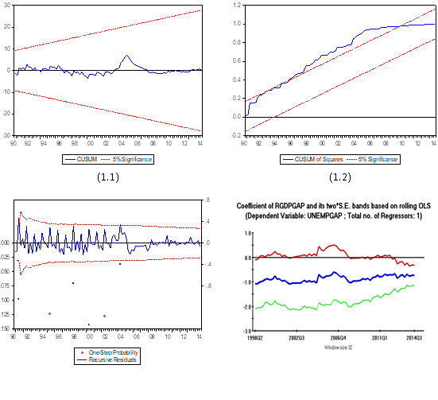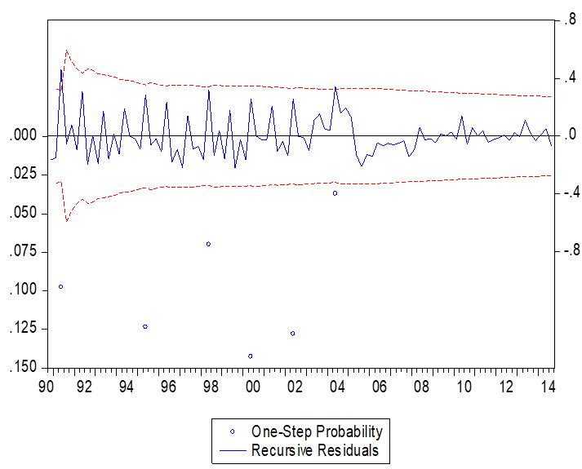
Figure 1. (left) this figure is blurry, which is unacceptable; (right) this figure has a higher resolution. However, the labels are not formatted using Times New Roman font. (Font = 9; Click ‘Caption B’ on the Styles Gallery)

Socio-economic factors
Savings to income ratio
Financial status
Income adequacy
Financial literacy
Financial behaviour
Debt burden
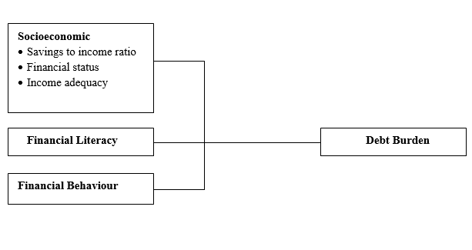Figure 2. (left) this framework is a non-editable diagram, appears blurry and hence, is unacceptable;
(right) this framework is built using Ms Word illustration tools, has higher resolution and is acceptable.
(Font = 10; Click ‘Caption B’ on the Styles Gallery)
Please use the ‘drawing canvas tool’ in Ms Word before inserting any images or diagrams into the document. When constructing a conceptual/theoretical framework, please use editable or vector-based diagrams. Draw diagrams using Ms Word’s Smart Art Graphic Tool (textboxes, labels, arrows, legends, etc.) rather than embedding non-editable image objects. Ensure that all the figures have a good resolution (minimum 300dpi) and are not fuzzy or blurry.

  - Captions

The figure number and caption should be typed below the illustration in 9pt and left justified. Artwork has no text along the side of it in the main body of the text. However, if two images fit next to each other, these may be placed next to each other to save space, see Fig 1. They must be numbered consecutively, all figures, and all tables respectively.

- Equations and formulas

Equations and formulae should be typed and numbered consecutively with Arabic numerals in parentheses on the right-hand side of the page (if referred to explicitly in the text). They should also be separated from the surrounding text by one space. If you chose to use the Equation Editor, please ensure that the manuscript is saved using .docx format (rather than .doc), and Compatibility Mode is turned off.

 | Rt = K EP = 93.02 (±9.62) – 13.45 | (1)

Funding Declaration
Authors are required to include a Funding Declaration section in their manuscript, placed after the Conclusion. This section must state whether external financial support was received for the research, including any grants, institutional funding, or sponsorships.
- If your research was funded, use:
“This research was funded by [Full Agency Name] under Grant No. [Grant Number].”
- If no funding was received, use:
“This research received no external funding.”

Acknowledgements

This section is compulsory. The following is an example of an acknowledgement statement:

The author/s would like to acknowledge the support of Universiti Teknologi MARA (UiTM), Cawangan Negeri Sembilan, Kampus Kuala Pilah and Faculty of Applied Sciences, Universiti Teknologi MARA, Shah Alam, Selangor, Malaysia for providing the facilities and financial support on this research.

The funding or grant-awarding bodies is acknowledged in a separate paragraph. For single agency grant: "This work was supported by the [Name of Funding Agency] under Grant [number xxxx]

Conflict of interest statement

This section is compulsory. The following is an example of a conflict-of-interest statement:

The authors agree that this research was conducted in the absence of any self-benefits, commercial or financial conflicts and declare the absence of conflicting interests with the funders.

References

Please ensure that every reference cited in the text is also present in the reference list (and vice versa).

Authors are also required to cite at least ONE (1) article that were published in the Journal of International Business, Economics and Entrepreneurship (JIBE).

Chapters in book
Mettam, G. R., & Adams, L. B. (1994). How to prepare an electronic version of your article. In B. S. Jones, & R. Z. Smith (Eds.), Introduction to the electronic age (pp. 281-304). E-Publishing Inc.

Book
Barras, R. (2002). Scientists must write: A guide to better writing for scientists, engineers and students (2nd ed.). Routledge.
Journal article
Abdul Ghofur, R., Madnasir, Anggraini, E., Nurlaili, & Mohd Abas, M. K. (2023). Optimisation of Waqf Contribution Awareness among Indonesian Workers Through Digital System. Journal of International Business, Economics and Entrepreneurship, 8(2), 1–6. https://doi.org/10.24191/jibe.v8i2.24610
Anggraini, F., & Purnama, A. I. (2024). ICT and Entrepreneurial Orientation as Drivers of SME Performance: Insights from Padang Pariaman Regency, Indonesia. Journal of International Business, Economics and Entrepreneurship, 9(2), 75–91. https://doi.org/10.24191//jibe.v9i2.2417

Conference proceedings
Dusuki, A. W. & Dar, H. (2007). Stakeholder's perceptions of corporate social responsibility of Islamic banks: Evidence from Malaysian economy. In M. Iqbal, S. S. Ali & D. Muljawan (Eds.), Proceedings of the 6th International Conference on Islamic Economics and Finance (pp. 249-277). Jeddah, Saudi Arabia: Islamic Development Bank.

Note: Please refer to this website for more examples on APA (7th edition) referencing: https://libraryguides.vu.edu.au/apa-referencing

 | © by the authors. Submitted for possible open access publication under the terms and conditions of the Creative Commons Attribution (CC BY-NC-SA) license (https://creativecommons.org/licenses/by-nc-sa/4.0/deed.en).

An example appendix

Authors including an appendix section should do so after References section. Multiple appendices should all have headings in the style used above. They will automatically be ordered A, B, C etc.

- Example of a heading within an appendix
  - Example of a sub-heading within an appendix

There is also the option to include a subheading within the Appendix if you wish.

About the Authors

Please submit another separate file by naming it as “Author Information”. Avoid revealing the identity and information of the authors in the manuscript (that should be anonymous). Provide the following information in the separated file.

Author 1 (Full Name, without Titles/Designation), Please summarize the academic background and details of the author, and contact information (an e-mail address is compulsory for the corresponding author). Please also include your 12-digit Orcid ID (visit http://orcid.org to register). The authors’ biographical information will be displayed after the Reference List. Maximum number of words is 100.

Author 2 (Full Name, without Titles/Designation), Please summarize the academic background and details of the author, and contact information (an e-mail address is compulsory for the corresponding author). Please also include your 12-digit Orcid ID (visit http://orcid.org to register). The authors’ biographical information will be displayed after the Reference List. Maximum number of words is 100.

EXAMPLE:
Danial Rashid, PhD is Associate Professor in the Department of Management and Finance at the University of Malaysia (ORCID: http://orcid.org/0000-0000-0000-0000). His main research activity is in the area of organizational innovation and organizational learning. He has published widely on these subjects in publications such as the International Journal of HRM, Journal of Business Research, International Journal of Information Management and Management Decision. His can be reached through his email at danialrashid@university.edu.

Authors’ contributions

This section is compulsory. Please submit this information in another separate file by naming it as “Author Information”. Each author contribution must be stated clearly reflecting each contribution to the body of the work and manuscript. There are fourteen types of author contributions. Some of these contributions (if not all) need to be specified and attributed to each of the author(s).
- Conceptualization
- Data collection
- Formal Analysis
- Funding acquisition
- Investigation
- Methodology
- Project administration
- Resources
- Software
- Supervision
- Validation
- Visualization
- Writing – original draft
- Writing – review & editing

For example:

Jaya Subramaniam carried out the research, wrote and revised the article. Rahmah Hassan conceptualised the central research idea and provided the theoretical framework. Both Rahmah Hassan and Chong Ju Lian designed the research, and supervised research progress. Rahmah Hassan anchored the review, revisions and approved the article submission.

General Instructions for the manuscript

Title
The title of the manuscript should be clear and representative (reflecting the content of the whole manuscript, the employed method, or the raised issue under study).

Author identities
The author’s full name without academic degrees and titles. Name of affiliation for each author accompanied by complete affiliation address, and corresponding email address.

Abstract
An abstract of maximum 300 words is required for any submitted manuscript. It is written narratively containing at least the aim(s), method, the theory used, and the result(s) of the research. It should be self-contained and must be citation-free. It should not contain any undefined abbreviations or unspecified references.

Keywords
Each manuscript should have 3 to 6 keywords. The keywords should help audience search the relevant literature to their interest.

- Introduction
The introduction should perform the relationship among the research background, rationale, justification of the research urgency, the emergence of research problems, alternative solutions, the solutions which are chosen, and the research aims. The background and rationale should be stated according to the theories, evidence, pre-survey and/or relevant research. It may also contain the narrative operational definition of the main constructs, variable, or terminologies used. Besides, the aim of the research/study should be written clearly.

- Literature Review

It presents the theory applied and the related literature on the previous researches on the topic. Related work of previous researchers should be presented. Minimum 10-15 good and recent works [not older than 10 years] *, should be presented. This section can be merged with the introduction section as well. Here the author can discuss the research gap that this study is going or willing to cover followed by the hypothesis. [if relevant to their study] Provide in-text citation in APA 7th edition guidelines style. [Easy and Free APA Citation Generator]. A wonderful guide to literature review is available by University of South California at https://libguides.usc.edu/writingguide/literaturereview
- Research Method

The method comprises of the design of the research, population, and sample, sampling techniques, procedures, instruments, data collection tools, and data analysis techniques. All of these components need to be detailed in a report format (past tense), except for general explanations and reference. Writing the definition of certain general terms related to the method used is not necessary.

- Findings and Discussion

The findings and discussion are presented in one part. Findings are the presentation of the research purely based on the analyzed data while discussion is the explanation of the findings relevant to the literature discussed in the introduction and other relevant theories and ideas. The author(s) is/are required to provide the findings and discussion on the same sequence with the research aims, and, should also provide the summary of the discussion aimed at answering the grand question of the research at the end of the discussion part.

- Conclusion (and implications, recommendations, or suggestions, if any)

The conclusion should answer the objectives of the research. Tells how your work advances the field from the present state of knowledge. Without clear Conclusions, reviewers and readers will find it difficult to judge the work and whether it merits publication in the journal. Do not repeat the Abstract or list experimental results. Provide a clear scientific justification for your work, and indicate possible applications and extensions. It would help if you also suggested future experiments and/or point out those that are underway

Funding Declaration

Authors are required to include a Funding Declaration section in their manuscript, placed after the Conclusion. This section must state whether external financial support was received for the research, including any grants, institutional funding, or sponsorships.
- If your research was funded, use:
This research was funded by [Full Agency Name] under Grant No. [Grant Number].
- If no funding was received, use:
This research received no external funding.

Acknowledgements

The following is an example of an acknowledgement statement:

The authors would like to acknowledge the support of Universiti Teknologi MARA (UiTM), Cawangan Negeri Sembilan, Kampus Kuala Pilah and Faculty of Applied Sciences, Universiti Teknologi MARA, Shah Alam, Selangor, Malaysia for providing the facilities and financial support on this research.

Conflict of interest

The following is an example of a conflict-of-interest statement:

The authors agree that this research was conducted in the absence of any self-benefits, commercial or financial conflicts and declare the absence of conflicting interests with the funders.

References

All references referred to in the article text must be listed in the reference section. The references shall contain at least 15 (fifteen) references from primary sources (scientific journals, conference proceedings, research reference books) or 80 % of total references, which are published within 5 (five) years. The citation format and the references must follow the APA 7.0 style.
Please ensure that every reference cited in the text is also present in the reference list (and vice versa).
Authors are also required to cite at least 2 (two) articles that were published in the Journal of International Business, Economics and Entrepreneurship (JIBE).

© by the authors. Submitted for possible open access publication under the terms and conditions of the Creative Commons Attribution (CC BY-NC-SA) license (https://creativecommons.org/licenses/by-nc-sa/4.0/deed.en).

Note: Please include the above copyright disclaimer and logo in your manuscript.

Style Formatting: Special Instruction to Authors (Please read this)
- Authors are required to edit the template using Microsoft Word 2010 onwards.
- Authors must use the ‘Styles Gallery’ to format the written contents of the article.
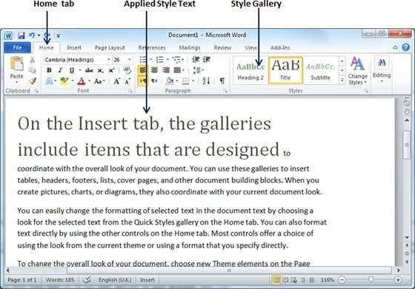
- The Styles Gallery is located within the Home Ribbon, in the Styles Pane.

- The ‘Styles Gallery’ appears as follows:
- Please utilize the Styles Gallery when formatting your article.
- Please avoid doing the following:
  - adjust the paragraph parameters
  - add numbering to headings
  - increase or decrease indentation
  - create new headings

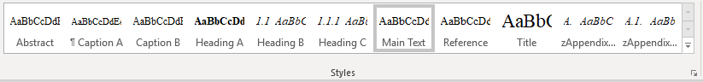

- If the formatting appears to stray away from the requirements, select the affected paragraphs/headings, and click the “Clear Formatting” icon at the ‘Font’ section of the ‘Home’ ribbon.

- The formatting will be reset. Again, apply the intended formatting by clicking the specific style using the Styles Gallery.
Please refer to the table below to understand the target use of each of the specific style.
Style Name | Targeted Use
Title | Main title
Author | Authors’ names  *corresponding author’s details are located at the footnote section of the first page
Affiliation | Author’s institutional affiliation
Footnote | Corresponding author’s e-mail address (use institutional e-mail address instead of free e-mail such as gmail, yahoo etc.)
Heading A | Main header with numbering (1,2,3…)
Heading B | Second level header (e.g. 1.1, 1.2, …)
Heading C | Third level header (e.g. 2.2.1, 2.2.2, …)
Main Text | The write-up of the article
Caption A | Caption for Table
Caption B | Caption for Figure
Reference | Bibliographic reference with indentation
zAppendix Heading 1 | Appendix header with lettering (A. B, C …)
zAppendix Heading 2 | Appendix second-level header with alphanumeric coding (e.g. B1. B2, B3 …)

- If you successfully adhere to this instruction, your article will be generated into a bookmarked PDF that is easy to be navigated by readers.
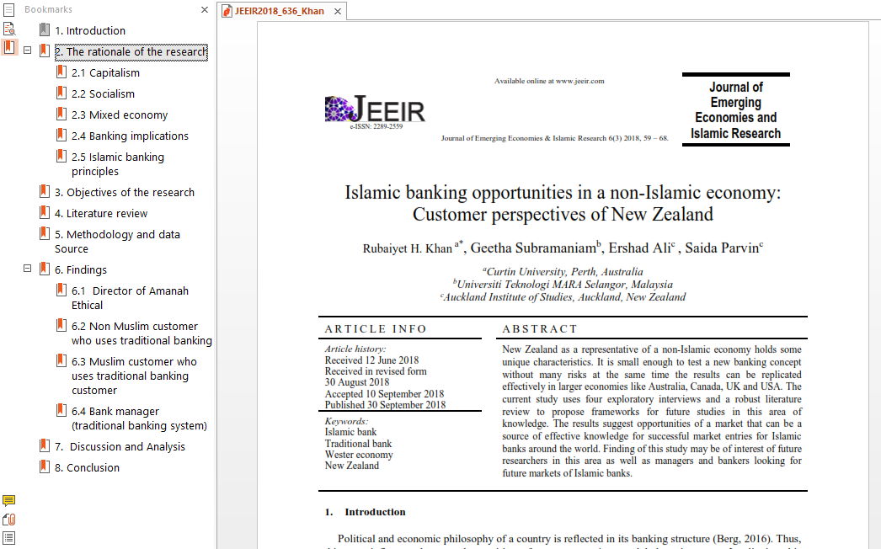

- This journal is a double-blind peer-reviewed open access journal that does not charge any publication fees. The journal is managed by volunteering academics of UiTM whose responsibilities include teaching, research, supervision, administration, and other academic obligations. Hence, your adherence to this guideline when submitting your manuscript is highly appreciated.

Prepared by:
Muhammad Iskandar Hamzah, Ph.D.
Universiti Teknologi MARA (UiTM), Malaysia
February 2022

